**ADVANCE NETWORK AND SECURITY**

**An Enterprise Network of a Hospital**

1. Table of Enterprise Edge.

|  |  |
| --- | --- |
| CORE | 3rd floor Admin area and the sales dept. |
| DISTRIBUTION | 1st floor ASA server |
| ACCESS | -1 and 2nd floor pcs in different areas |
| ENTERPRISE EDGE | Client accesses the hospital from an outside network through an ASA firewall. |

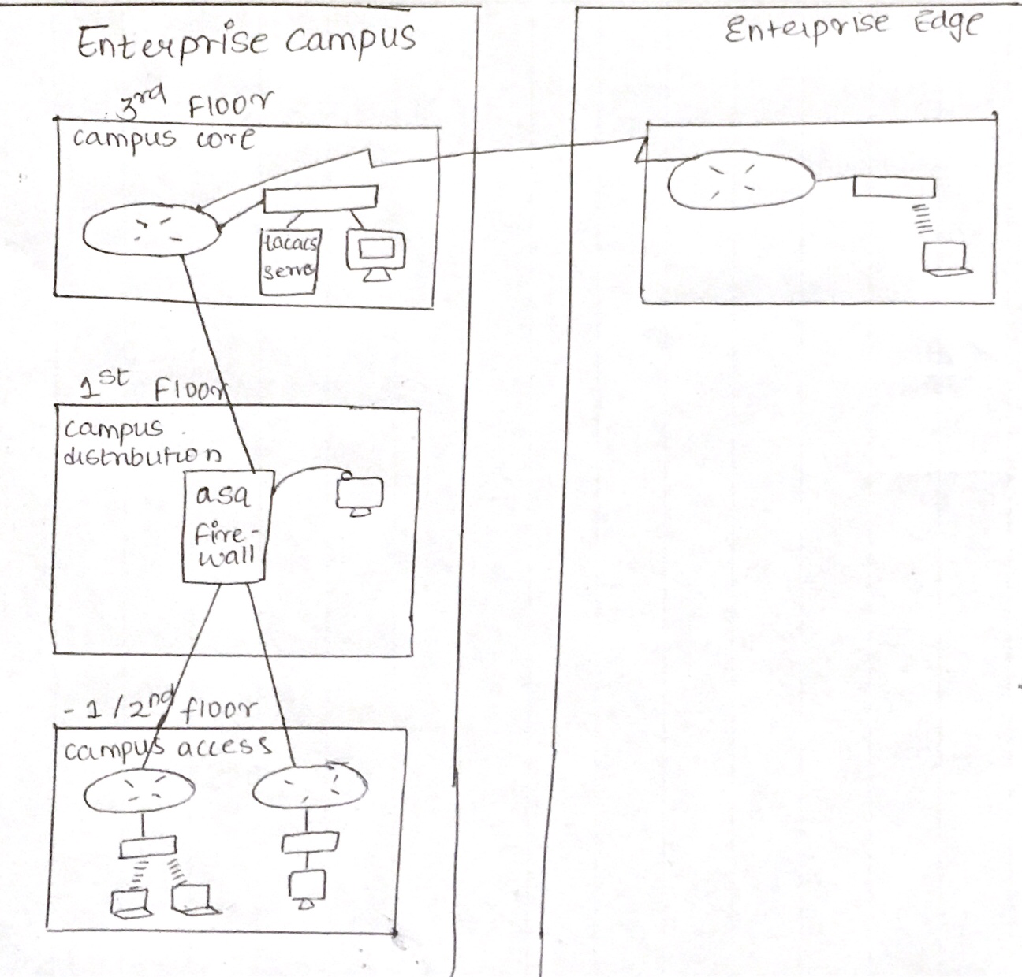

The core layer is where the admin has access to his private network along with the information of the entire member’s, doctors and employees who work in the hospital.

The distribution layer is placed on the 1st floor is because many people will access, from an outside network to an inside network. Intrusion can also take place here, this can also be considered as the core layer part of the network.

The Access layer contains all the normal floors which includes emergency/mortuary on -1 floor and the patients floor with the doctor’s office.

1. Connectivity.

I have used the 5 connectivity types in my network.

* Copper Straight- through,
* Serial DCE (for connecting 2 or more router’s),
* Copper Cross Over (Switch to Switch),
* IoT Custom Cable (for the IoT device connectivity) and
* Console

1. Security.

SSH, tacacs+, asa firewall, local login, vlans.

My core layer is highly secure which is located at the 3rd floor of the hospital building which has 2 sections:

1. The Admin Area and
2. The Sales Area.

The Distribution layer is placed at the 1st Floor which has 2 sections:

1. The ASA (Adaptive Security Appliance),
2. The Diet Office aka Cafeteria.

The 2nd and -1st Floor of the hospital are normal floors, which are the access layers. 2nd floor has the patient’s rooms, and -1 is the mortuary or the emergency floor.

1. The 2nd Floor:

This floor has 2 parts:

1. The Doctors office and
2. Operation Theatre rooms, normal wards.
3. Case Study:

*Explanation of core layer (3rd floor):*

The admin area is where the Tacacs+ configuration has been implemented because; the admin would have access to his crucial information which only he/she can access with a username and password.

The sales dept. is the area which has all the information about the employees and doctors who work in the hospital, which is ultimately connected to the admin area. This network is internally divided into Vlans (Vlan10, Vlan20, Vlan 30 and Vlan 40). Vlan 30 is connected to a printer. Vlan 40 is an Access Point through which 2 laptops are connected further. So the admin can get all the information about each staff member, nurses and the doctors.

*Explanation of distribution layer (1st floor):*

The area where the ASA firewall is configured is implemented there because, that is the part of the hospital where people come and fill the forms and do the payment of money (if any operation/surgery is carried out).

ASA is configured with NAT, DNS. It basically is the ISP.

Waiting place for everyone will also be there, that is why the cafeteria is placed there, where people who are waiting can also take advantage of the delicious food and meals.

Diet Office is an area where food is supplied to the patients on the 2nd floor of the hospital via IP-Phone calls where each phone is assigned a number (1000, 2000, and 3000). These phones can also be accessed by the patients at the 2nd floor.

Since this is where the Kitchen will be, so in case the kitchen catches fire, 4 IoT devices are connected:

1. Camera’s:

These cameras will work when the Motion detector detects someone coming inside.

1. Motion detector:

On when anyone enters or it might be an intruder who tries to enter.

1. Smoke detector’s

When smoke more than 1 level is detected the siren automatically starts to beep and the fire sprinkler is automatically on.

1. Siren:

Starts when the smoke detector detects more smoke that’s specified in the NTP Server.

1. Fire sprinklers:

Starts to water the area when smoke is detected.

*Explanation of access layer’s:*

Since this floor is for the OT and normal wards patients, there should be a doctor’s office situated nearby. I have configured a “local login” one for each doctor, this is because every doctor will have a list of patients he/she are treating and the patient’s information in their PC (with their own login and password).

This office is then connected to the 1st floor ASA router, which has all the information of which patient is being treated and have paid and the 1st floor is further connected to the -1 floor /emergency floor.

Patient’s room has a wireless router connected to Laptops in each room for the doctors to give them internet access while they are treating the patients. And each patient’s room has phones connected to the cafeteria on the 1st floor.

Each phone is assigned a number (100, 200, and 300).

The mortuary/Emergency floor is where 2 cars are acting as ambulance’s, an emergency door(which is always open).

An Access point which gives internet to many devices which is turn connected to a server(FTP AND SMTP) . This floor devices give all the details to the first floor trough the FTP or SMTP servers used devices making them aware who entered the emergency room and various kind of information’s.

1. Protocols used:

In my Network I have used

1. FTP:

Used for file transferring between 2 different networks.

1. SMTP(Emails):

Used for sending emails.

1. NTP:

Used for the IoT devices used as well as the local storage of data. This shows the current time and data on the IP-Phones used .

1. SSH(Local Login):

Used so that for every doctor there is a separate username and password when the doctor enters his/her office.

1. AAA(tacacs+):

Crucial admin data are stored here which only one person knowing the password can access.

1. VLAN:

Vlans are used for security internally among the same network.

1. RIP:

Used for communicating between 2 networks.

1. NAT:

Used with the ASA firewall because people will access the hospital via the outside public network which the NAT translates and the firewall scans the packet before allowing the packet to enter.

NTP:

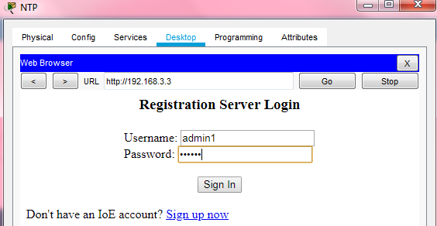

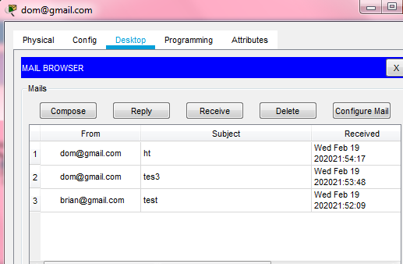FTP AND SMTP:

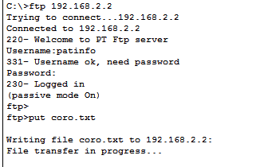



ASA: from PC2 to Server

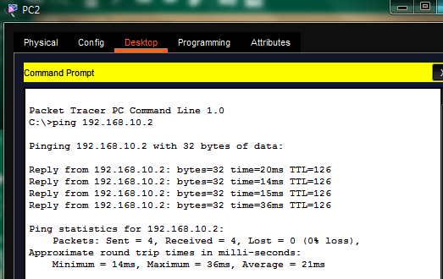

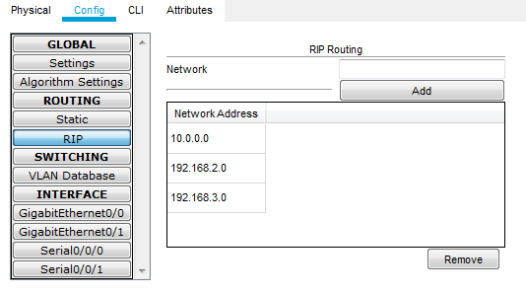RIP

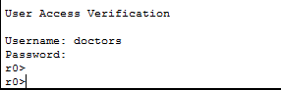 LOCAL LOGIN

VLAN 10,20,30:

|  |  |
| --- | --- |
| Ping from same vlan pcs and 2nd ping from pcs in different vlans | When pc pings to the patients laptops |
|  |  |

TACACS+

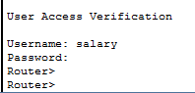

1. Topology:

**My Topology basically starts with -1 floor followed by the 1st floor and so on…**

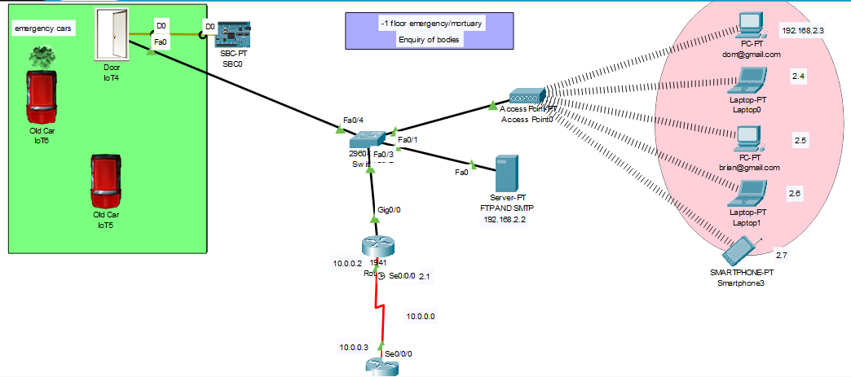

**-1st Floor:**

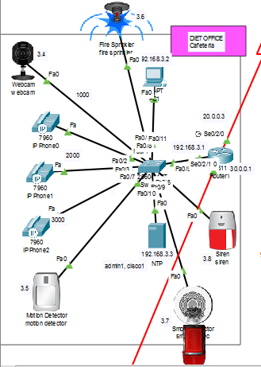1st floor For all IoT devices (press Alt enter)

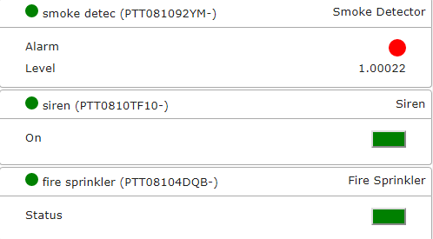

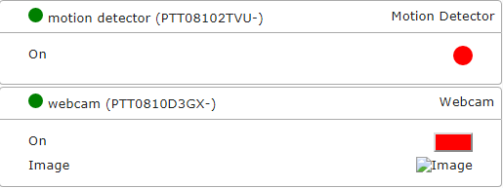

**Call from 1000 to 2000**

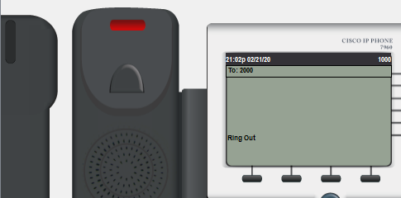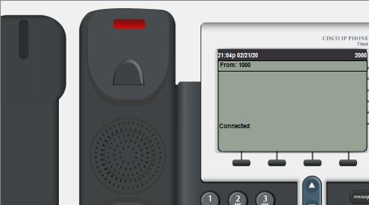

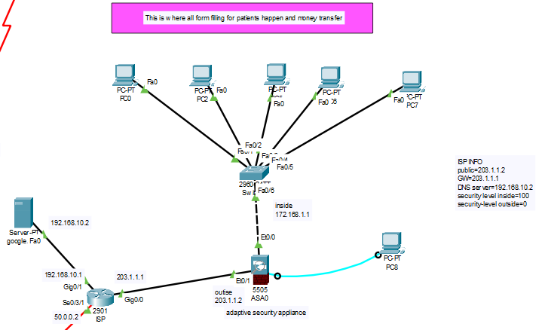

**2nd floor**

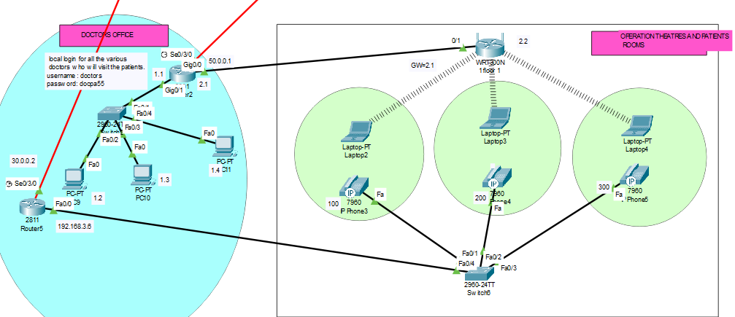

**3rd Floor**

